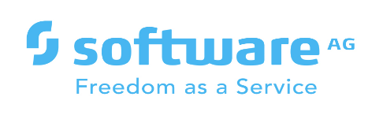

**webMethods CloudStreams Provider for SPLITWISE**

Version IS 10.11 | January 2022

Contents

1 Document Change History 3

2 What is webMethods CloudStreams Provider for <SaaS Name>? 4

3 Steps to create the connector connection 5

4 webMethods CloudStreams Provider for <SaaS name> Connector 6

4.1 Connector Details 6

4.1.1 Supported Resources 6

4.1.2 Usage Notes 6

# Document Change History

|  |  |
| --- | --- |
| **Document revision date** | **Summary of changes** |
| January 2022 | First release of this document. |

# What is webmethod’s Cloud Streams Provider for Splitwise

**Splitwise** is a free tool for friends / roommates to track bills and other shared expenses, so that everyone gets paid back. **If a group needs to share the cost of a particular bill, Splitwise ensures that anyone who pays is reimbursed the correct amount and with a minimal number of** transactions.   
  
Splitwise connector for webMethods enables connectivity to splitwise and perform operations such as get user information. Create, Read, Update, Delete and Undelete expenses.

**Capabilities of wm.io splitwise Connector**

* To establish OAUTH 2 Connectivity with Splitwise API SAAS Provider.
* Make requests to Get user or expense Information
* Create new expenses
* Update expenses
* Delete / Undelete expenses

# Steps to create the connector connection

## Getting a Splitwise API Key

If you haven't already, [sign up](https://www.splitwise.com/signup) for a Splitwise account. It's free to get started.

* Once signed up and logged in, click on your name > Your Account on the top right-hand side

* Under Privacy & Security, Click on Your Apps and then Click on **Register Your Application**

* Fill in the form with Application Name, Description, URL, Callback URL etc and Click Register.

This will create Consumer Key and Secret and an option to create an API Key as per below screenshot. The details of OAuth 1.0 and 2.0 URLs are also shown.

This information can be used to configure the connection in webMethods On-Premise / Cloud,

## Installing Connector

You need to use the previously created Connector package or download the Connector package from

Install the Connector package on **Integration Server**  
To know how to install the package on Integration Server

## Creating Connection for SaaS Application

To create a Connector for SAAS application, you need to switch to Cloudstreams perspective.

* Create a new CloudStreams Provider Project as below:  
  Graphical user interface, text, application, email

  Description automatically generated

Contd..

* Project needs to be configured as below. Can be imported via OpenAPI spec file / URL using the options and choose authentication mechanism  
  Graphical user interface, text, application, email

  Description automatically generated
* Connection is established as below:  
  Graphical user interface, text, application

  Description automatically generated
* Configure the authentication as per the SAAS API spec  
  Graphical user interface, text, application, email

  Description automatically generated
* Configure the Resources request and responses as per the API Spec:  
  Graphical user interface, text, application

  Description automatically generated
* Once all the resources has been configured, Publish the Connector to the IS and webMethods,io Cloud (below ss):  
  Graphical user interface, text, application, email

  Description automatically generated
* Follow the publish process, by selecting the Connector  
  Graphical user interface, text, application, email

  Description automatically generated
* Select Targets and Click Next (Below On-Prem and cloud have been pre configured in designer using preferences)  
  Graphical user interface, text, application, email

  Description automatically generated
* Set the below options to True to Enable Connector, Display and Enable custom action in cloud and click Finish  
  Graphical user interface, text, application

  Description automatically generated
* The Connector should now be published to both On-Prem and Cloud.

3.4 Creating Connections to the new Connector:

* On-Prem Connector should appear as below:  
  Graphical user interface, application

  Description automatically generated
* Clicking on the above Connector name and Click on Create new connection and provide required information > Test. The connection should be successfully enabled and good to be invoking resources  
  Graphical user interface, text, application, email

  Description automatically generated
* For Cloud, in a new workflow, search for the connector name, drag and drop it to the Workflow and configure as below:  
  Graphical user interface, text, website

  Description automatically generated
* Click the + Button:  
  Graphical user interface, text, application

  Description automatically generated
* Pop-up appears to connect to an account, click + Button. Provide the required information, Test and the connection should be configured successfully  
  Graphical user interface, text, application, email

  Description automatically generated
* Configured connections should showup as below:  
  Graphical user interface, application

  Description automatically generated

**3.5 Using the Connections to Invoke the Resources (Cloud):**

* Drag and drop the newly configured connector and click on settings  
  A screenshot of a computer

  Description automatically generated
* Click + to add action, Select the newly created connection from dropdown, Provide a name and description for the resource  
  Graphical user interface

  Description automatically generated
* Select the Operation from the list of available resources, Headers and Parameters can be verified / amended. Click Next and Confirm the Custom action  
  Graphical user interface, text, application

  Description automatically generated
* Now, the action is created, we would need to provide inputs, first select action and authentication created earlier from dropdown:  
  Graphical user interface, text, application, email

  Description automatically generated
* Provide inputs and click next:  
  Graphical user interface

  Description automatically generated
* Test this action using the Test Button as below and you should receive an output:

Output:

* Configure the Workflows as per your requirement. Below are some of the example workflows configured in wmioconnectorsdev.int-az-us.webmethods.io with Project Name Srinidhi. Below has the screenshots of the workflow and validation done in the SAAS UI

+

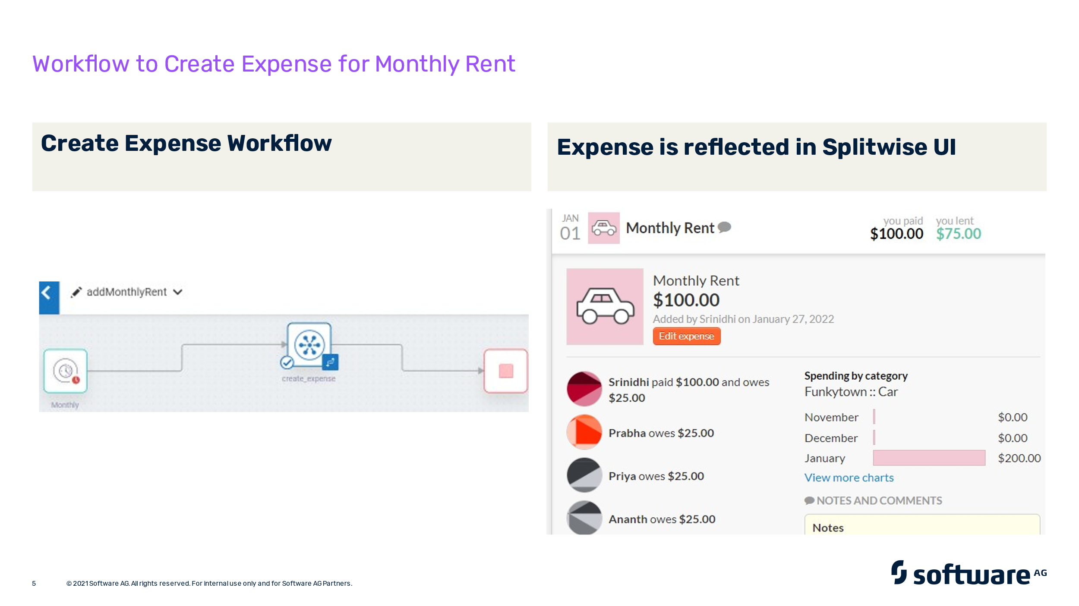



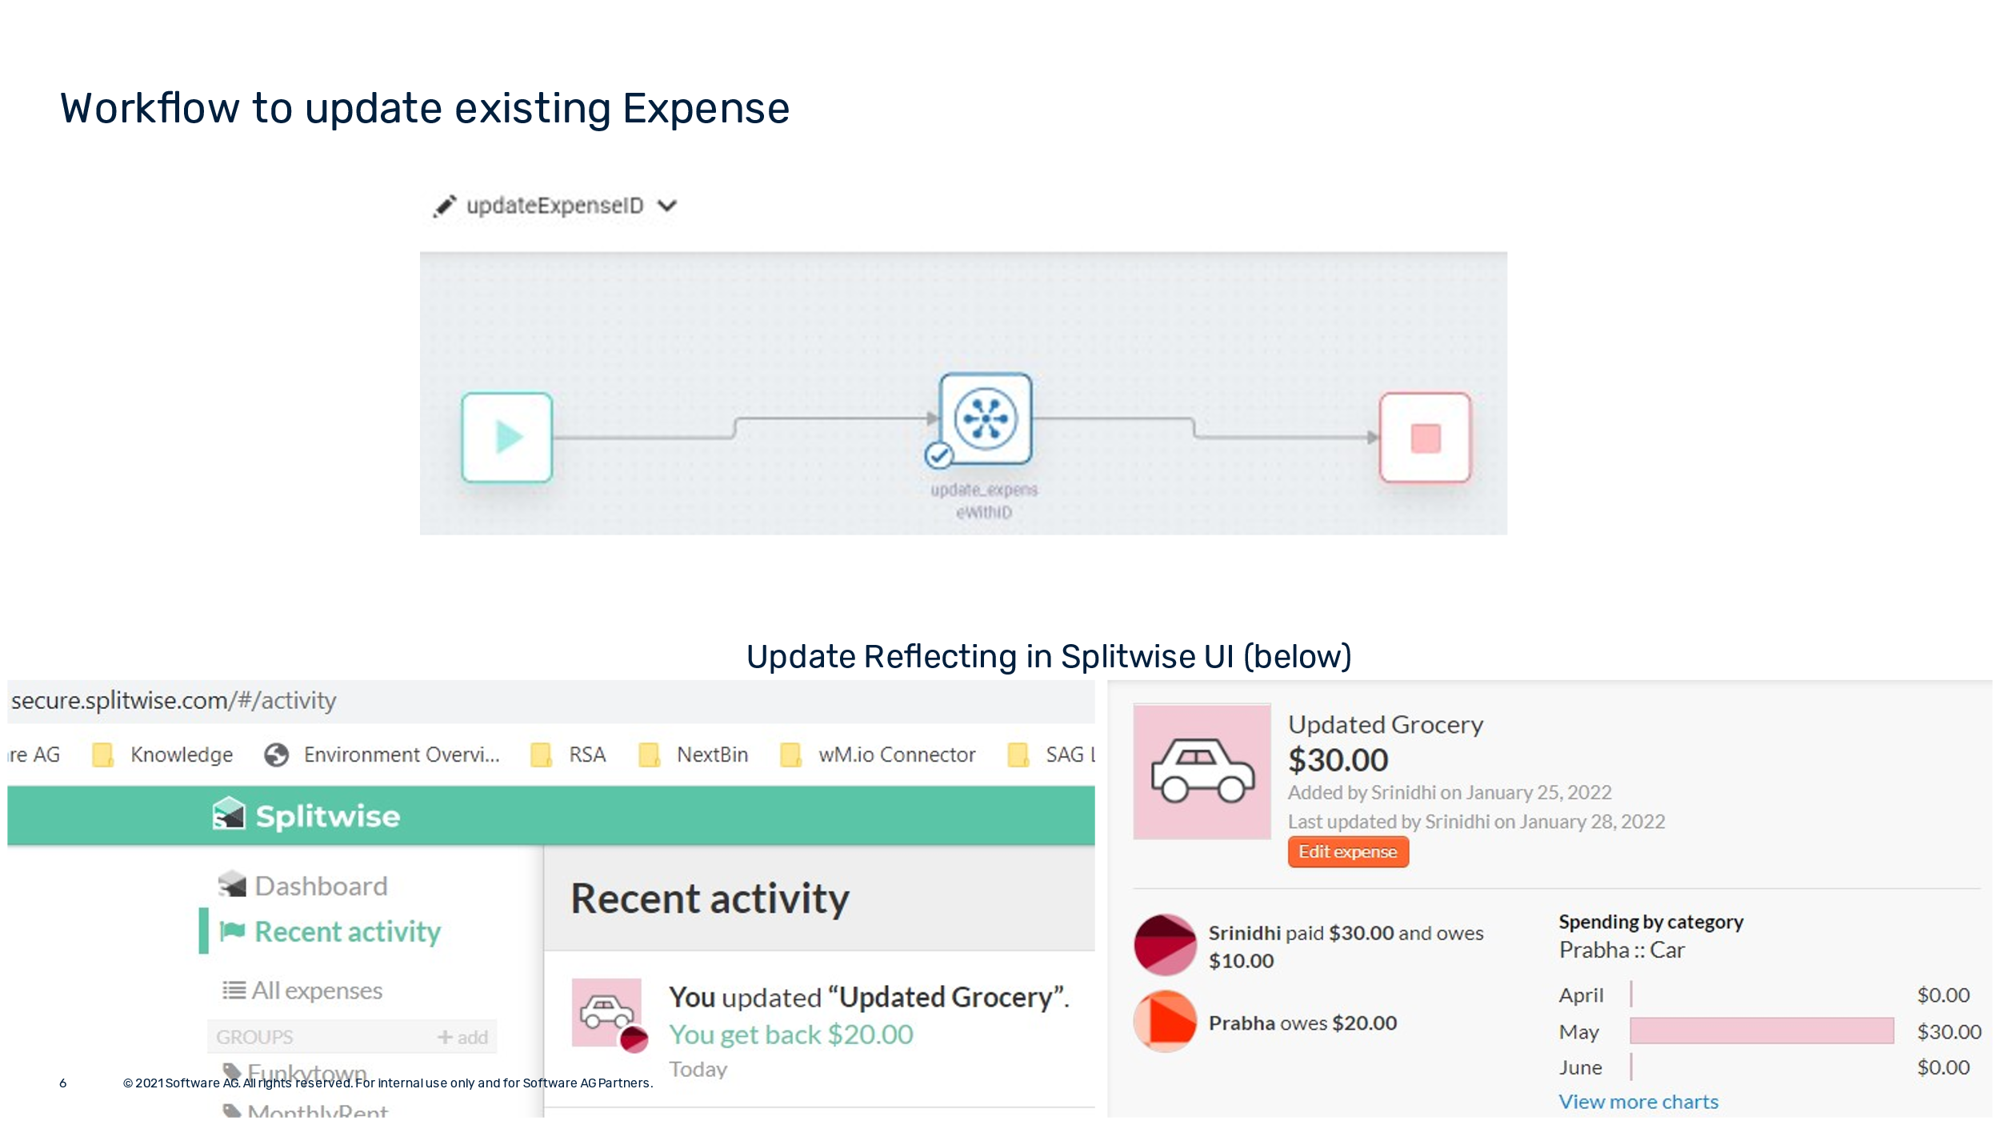 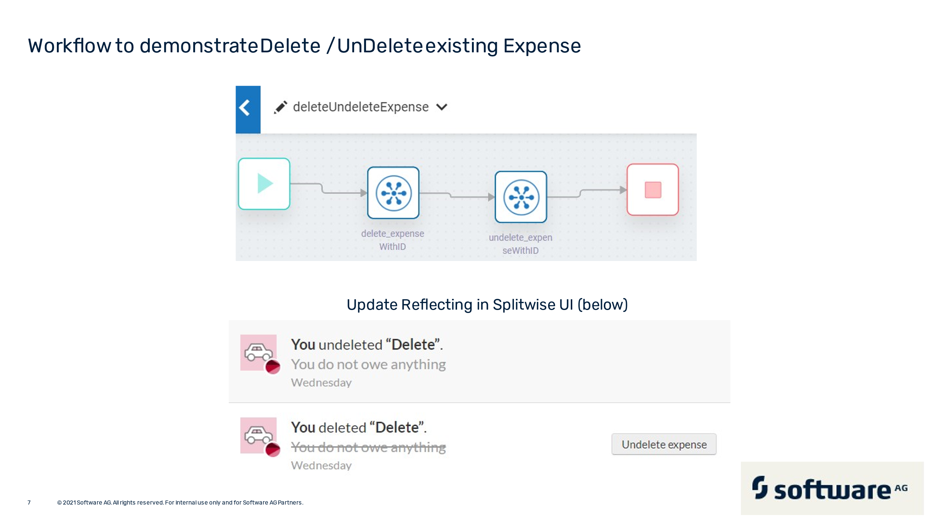

**3.6 Using the Connections to Invoke the Resources (On-Prem):**

* Right click on the folder where you want to create a CloudConnector service and   
  Graphical user interface, text, application, email

  Description automatically generated
* Configure element name  
  Graphical user interface, text, application, email

  Description automatically generated
* Select the Connector  
  Graphical user interface, application

  Description automatically generated
* Select Connection Pool and click finish  
  Graphical user interface, text, application, email

  Description automatically generated
* A Connector service is created. Now, in the Resource, select Resource name as below and click Finish:  
  Graphical user interface, text, application

  Description automatically generated
* Run the connector service by the button or Ctrl + R, Providing required inputs should get the outputs from the SAAS resource as below:  
  Graphical user interface, text, application, email

  Description automatically generated
* Similarly other Resources can also be configured.

## webMethods CloudStreams Provider for Kickbox Connector

## Connector Details

The connector details include:

* **SaaS Provider**: Splitwise
* **API Version**: 3.0.0
* **API Type**: REST
* **Developer**: Srinidhi B A
* **Group**: NA
* **CloudStreams Minimum Version Compatibility**: 10.11
* **Provider Package Name**: WmSplitwiseProvider

### Supported Resources

List down resources supported by the provider:

|  |  |  |  |  |
| --- | --- | --- | --- | --- |
| **Tenant** [**https://wmioconnectorsdev.int-az-us.webmethods.io/**](https://wmioconnectorsdev.int-az-us.webmethods.io/) **Project : Srinidhi** | | | | |
|  | **Name** | **Path** | **Method** | **Description** |
| 1 | Get Current User Info | /get_current_user | GET | Get Information for Current User |
| 2 | Get Information of a Friend | /get_user | GET | Get Information of a Friend using ID |
| 3 | Get Expenses | /get_expenses | GET | Get Expenses of Current User |
| 4 | Create a New Expense | /create_expense | POST | Create a new expense |
| 5 | Update Expense | /update_expense | POST | Create an existing expense by ID |
| 6 | Delete Expense | /delete_expense | POST | Delete an existing expense by ID |
| 7 | Undelete / Recover Expense | /undelete_expense | POST | Undelete already deleted expense by ID |

### Usage Notes

Refer to the video instructions at :

https://sagportal-my.sharepoint.com/:v:/g/personal/srb_softwareag_com/EWhl7FvNJ49NuGDCVTe7u98B6B3gm27DcUIpMUrekcggDw